Pytest-Smell: a smell detection tool for Python unit tests
https://dl.acm.org/doi/10.1145/3533767.3543290

Team members: Contiu Mario-Samuel, Colev Thomas-Daniel, Enache Vlad
Use-case:
It’s a tool that is used to detect unit-test problems for Python without the need for an IDE and works with pytest.
Installation:
The tool is very easy to install because it’s a python library that can be installed using:
“pip install pytest-smell”. It doesn’t have any dependencies:
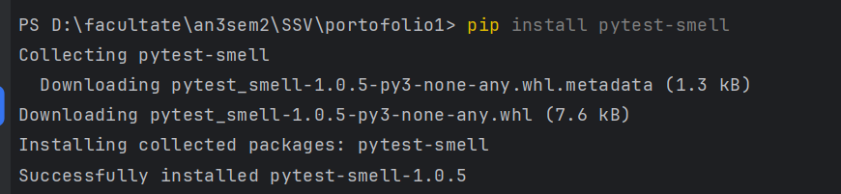
Usage
Pytest-smell is easy to use because you just have to run pytest-smell in the directory where your tests are present, and it will detect problems that your unit-tests may have, such as:
Duplicate Assert count
Eager Test count(tests where multiple features are tested)
Conditional Logic count
Exception Handling count
Sleepy Test count(tests with sleep statement)
Redundant Print count
Ignored Test count
Unknown Test count
Magic Number count
Assertion Roullete count(tests with multiple asserts that can fail)
For the following simple program, I made some unit-tests with some issues like multiple asserts in one unit-test, conditional logic, exception handling used, redundant print used and magic numbers used, and the tool was able to identify all of those issues.
